Exercise 1

- Interval Level. There is no true zero point for Fahrenheit.
- Ratio. The key thing separating interval and ratio data sets is the true zero point. It is possible for there to be no rainfall in a month which would act as a zero point
- Nominal as the data can only be organized by labeling
- Nominal, as this data can only be organized by labeling without order

Exercise 2
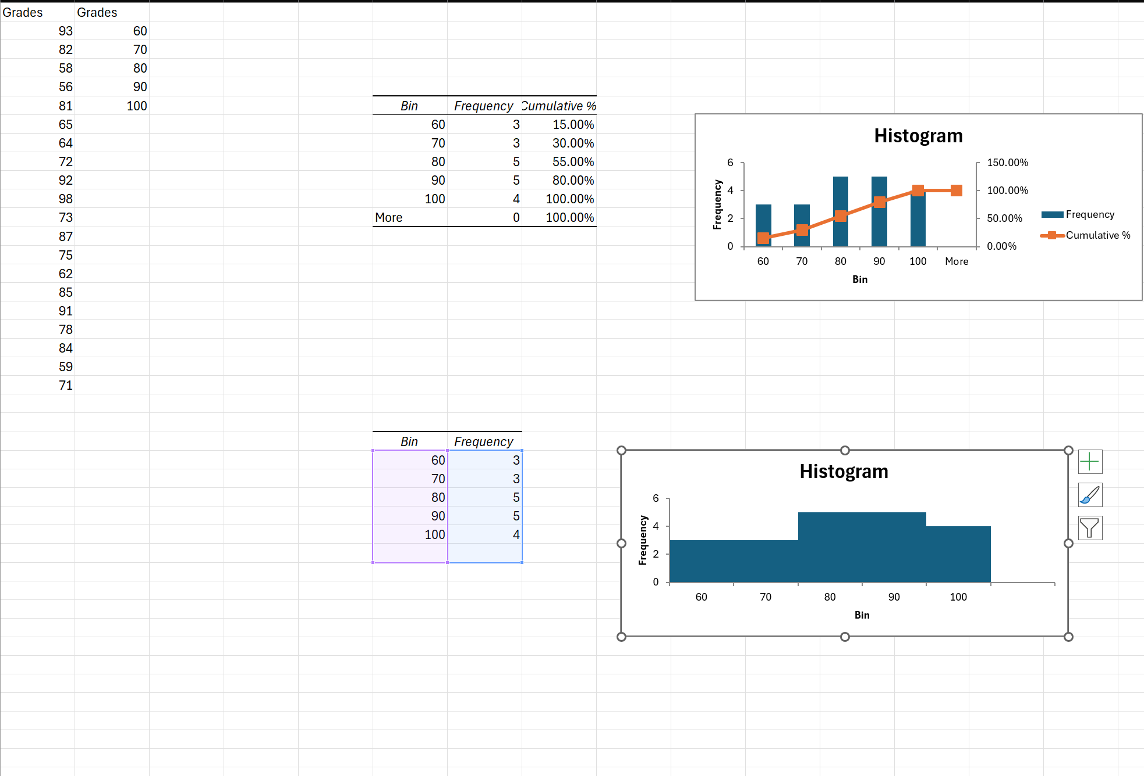

Exercise 3
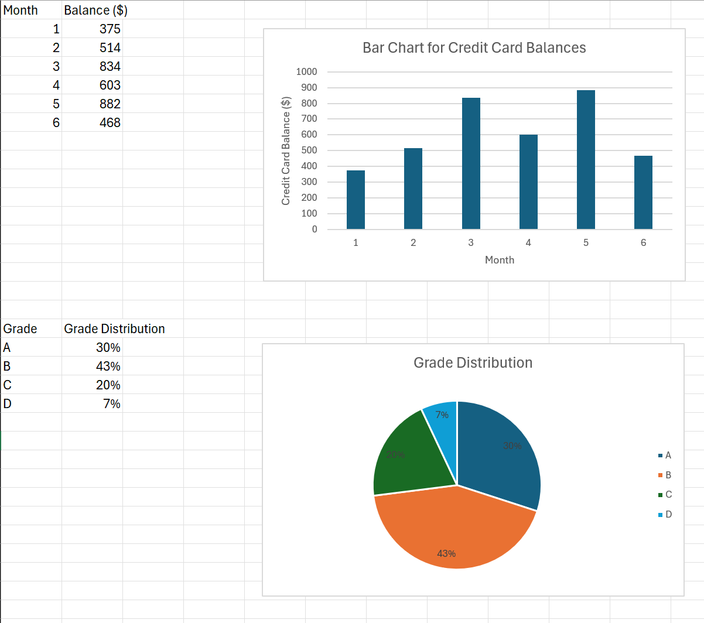

Exercise 4
Q1)
mean: 15.9
median: 17
mode: 24
Q2)
Mean: 81.7
Median: 82
Mode: 82
Q3)
Mean: 32.7
Median: 32.5
Mode: 36

Included is the Data Analysis I did during Exercise 5

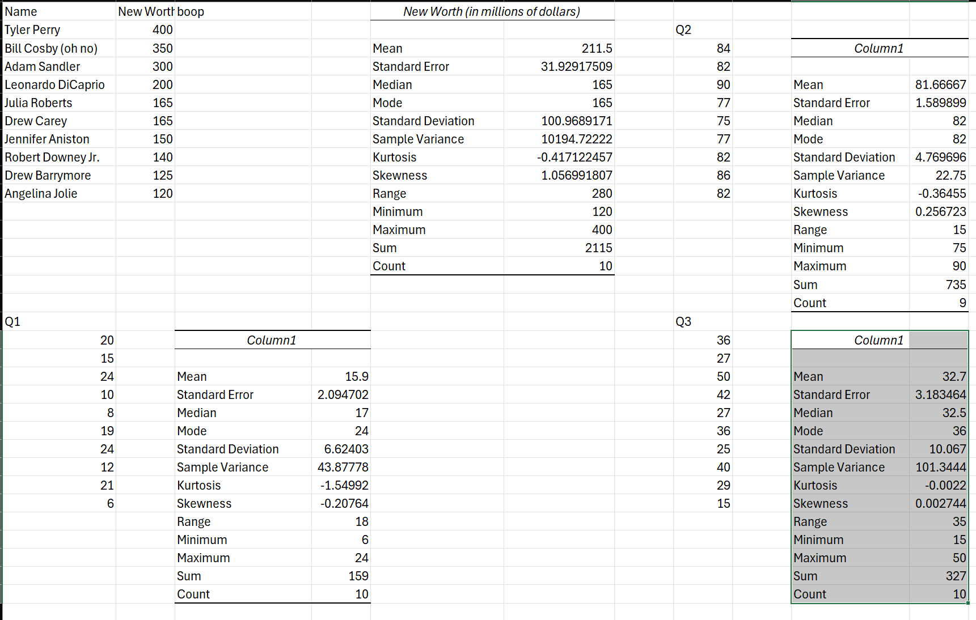

Exercise 5
Q1 |  |  | Q2
20 | Variance | 40.8 | 84 | Variance | 22.8
15 | SD | 6.39 | 82 | SD | 4.77
24 | Range | 16 | 90 | Range | 15
10 |  |  | 77
8 |  |  | 75
19 |  |  | 77
24 |  |  | 82
 |  |  | 86
 |  |  | 82
Q3 |  |  | Q4
36 | Variance | 75.4 | 8 | Variance | 14.2
27 | SD | 8.68 | 11 | SD | 3.77
50 | Range | 25 | 6 | Range | 13
42 |  |  | 2
27 |  |  | 11
36 |  |  | 6
25 |  |  | 5
40 |  |  | 6
 |  |  | 10
 |  |  | 15

